Overview

Punch Power Pro - Product Requirements
By, Christopher Jones

Punch mph or kph
Semi-transparent tab bar / bottom navigation bar (Spotify, looks cool)
I like gaussian blur, gradients, semi-transparancy

Break it down in terms of flows

Research
- https://sensortower.com/
  - Products (one time versus recurring)
  - Language support considerations for GTM
- Google Trends (Industry research and go-to-market insights regarding interest in different regions)
- Mobbin
- Whoop

User opens app on watch or phone
- When the app is opened on watch it should automatically open on phone
- No need for this behavior the other way around

First time opening the app
- User onboarding flow
  - I think we’re going to require onboarding first as:
    - We’ll need to be able to associate their metrics with an account
    - We’ll need weight (I think) to estimate punch force
      - Can we use Healthkit to get this?
    - Enabled personalized sharing (ie. Chris punches…)
  - Data required
    - Email
    - Weight
    - Age (for use in things like age brackets)
    - Goals (could this be useful in feature prioritization?)

User sees app open to main menu featuring a list of options:

Personal stats
- Highest punching force generated
- Number of punches in 10 seconds
- # in one minute
- Punching force over time (similar to scale)

Watch
- Arcade mode
- Training mode (workout)
  - Heart rate zones
- Freestyle (what is the difference between this and the above?)
- History
- Leaderboard

Phone
- Home (What are we trying to drive here? Engagement?)
  - Some top-level punching stats

- History
  - Previous workout sessions listed in reverse chronological order
    - Date | Values | Share
    - Allow swipe to delete
  - Trend view with line graph showing longitudinal data
- Contacts/Share/Club/Community
  - We’ll want something here to encourage sharing / engagement with the app
- Settings
  - Pretty standard account management stuff
    - Units Imperial or Metric
    - Membership management
    - Watch Face
    - Authorize health access
    - Widgets
    - Notificatoins
    - Siri shortcut
  - FAQs
  - Share this app with a friend
  - About Us
  - Rate App
  - Contact Support
  - App integrations (ie. Strava, Fitbit, Health)

Metrics
We can track all of this using Google Analytics, Mixpanel, Heap, or Amplitude.

Marketing
- Geographic location (country)
  - Number of downloads per country
- Demographic data
- Affinity categories

Product

1. User Engagement Metrics
- Daily Active Users (DAU) / Monthly Active Users (MAU)
Measures the number of unique users engaging with the app daily or monthly.
  - Why it matters: Indicates user retention and app stickiness.
  - Goal: Achieve a DAU/MAU ratio of 30% or higher.
- Session Frequency
The average number of sessions per user per week.
  - Why it matters: Tracks how often users return to engage with the app.
- Feature Usage Rate
Tracks the percentage of users engaging with core features, such as punch-force tracking or gamified challenges.
  - Why it matters: Helps identify which features resonate with users and guide improvements or promotions.

2. Performance Metrics
- Punch Data Accuracy
The percentage of successful and accurate punch-force measurements.
  - Why it matters: Validates the app's reliability and user trust in its functionality.
- App Latency
The average time it takes to display punch results after measurement.
  - Why it matters: A fast, seamless experience improves user satisfaction.

3. Retention and Churn Metrics
- User Retention Rate
The percentage of users who return to the app after a defined period (e.g., 7 days, 30 days).
  - Why it matters: Indicates long-term engagement and satisfaction.
- Churn Rate
The percentage of users who stop using the app over time.
  - Why it matters: Understanding why users churn can inform product enhancements.

4. Business Metrics
- Revenue per User (ARPU)
Tracks the average revenue generated from each user.
  - Why it matters: Helps gauge the profitability of subscription or in-app purchases.
- Subscription Conversion Rate
The percentage of free users who upgrade to a premium plan.
  - Why it matters: Indicates the app’s ability to deliver enough value for users to pay.
- Cost Per Acquisition (CPA)
The average cost of acquiring a new user through marketing or promotions.
  - Why it matters: Evaluates the efficiency of marketing efforts.

5. Community and Social Metrics
- Leaderboard Participation
The percentage of users engaging with gamification elements like leaderboards and challenges.
  - Why it matters: Measures community-driven engagement and competition.
- Social Sharing Rate
Tracks the number of users sharing their punch-force data or achievements on social media.
  - Why it matters: Indicates organic growth potential through user-generated promotion.

6. Customer Satisfaction Metrics
- Net Promoter Score (NPS)
Measures how likely users are to recommend the app to others.
  - Why it matters: Reflects user satisfaction and loyalty.
- App Store Ratings and Reviews
Aggregates user feedback and ratings from app marketplaces.
  - Why it matters: Impacts discoverability and influences new users.

7. Technical Metrics
- Crash Rate
The frequency of app crashes per session.
  - Why it matters: Ensures a smooth, reliable user experience.
- Battery Usage Impact
Measures how much battery the app consumes during operation.
  - Why it matters: Affects user perception and usability.

User journeys

Persona 1: Fitness Enthusiast
- Name: Alex Johnson
- Age: 28
- Occupation: Marketing Manager
- Hobbies: HIIT workouts, boxing-inspired fitness classes, and competitive gamification.
- Goals:
  - Track fitness performance in an engaging way.
  - Compete with friends and share achievements on social platforms.
  - Improve punching speed and power for personal fitness milestones.
- Frustrations:
  - Lack of integrated, data-rich apps for punch tracking.
  - Limited ability to compete with friends digitally.
  - Apps that don’t sync with their smartwatch or Strava.

User Journey
- Discover: Alex sees a social media post showcasing Power Puncher Pro’s leaderboard and punch analysis shared by a friend.
- Download & Onboard: Downloads the app and syncs with their smartwatch. Completes an interactive tutorial on measuring punch metrics and challenges.
- Engage: Competes in a weekly challenge with friends, uses the app’s analysis graphs to optimize technique, and shares punch speed records on Instagram.
- Retain: Unlocks achievements, sets personal records, and integrates workout history with Strava for a seamless fitness portfolio.

Persona 2: Combat Sports Practitioner
- Name: Marcus Lee
- Age: 35
- Occupation: MMA Coach
- Hobbies: Practicing martial arts, teaching classes, and testing new fitness tech.
- Goals:
  - Refine punching technique using data.
  - Track progress for both himself and students.
  - Discover tools to gamify student training.
- Frustrations:
  - Inconsistent or unreliable punch-tracking apps.
  - Lack of in-depth metrics like force, speed, and power.
  - Tools that don’t cater to professional-level users.

User Journey
- Discover: Learns about Power Puncher Pro through an article on "Best Apps for Martial Artists" on Reddit.
- Download & Onboard: Downloads the app, syncs with the smartwatch, and explores advanced features like Welltory-style graphs and velocity analysis.
- Engage: Analyzes peak force and average velocity during a sparring session. Creates a challenge for his students using the “Shoe Shine” feature to track rapid consecutive punches.
- Retain: Leverages in-app tutorials featuring Tony Jeffries to incorporate new drills into classes, and trains a custom ML model for personalized punch tracking.

Persona 3: Casual Gamer / Fitness Explorer
- Name: Sarah Patel
- Age: 22
- Occupation: College Student
- Hobbies: Video games, social media, and exploring fun fitness challenges.
- Goals:
  - Stay active in a fun and gamified way.
  - Compete with friends and share unique achievements online.
  - Discover interactive apps that integrate fitness and social gaming.
- Frustrations:
  - Apps that feel too serious or technical.
  - Lack of fun challenges in fitness tracking apps.

User Journey
- Discover: Finds Power Puncher Pro featured in a YouTube review of gamified fitness apps.
- Download & Onboard: Downloads the app and skips directly to "Fun Challenges." Completes a "Beat the Arcade Machine” challenge.
- Engage: Shares workout videos directly to TikTok and competes on the global leaderboard for the fastest punches in a minute.
- Retain: Regularly participates in themed challenges (e.g., "Punch Like a Pro Week") and earns achievements that unlock exclusive watch faces.

Persona 4: Fitness Content Creator
- Name: Jordan Harris
- Age: 30
- Occupation: Fitness Influencer
- Hobbies: Creating fitness content, engaging with followers, and exploring affiliate marketing opportunities.
- Goals:
  - Use cutting-edge tools to create unique content.
  - Monetize affiliate partnerships.
  - Inspire followers through data-driven fitness progress.
- Frustrations:
  - Generic apps without shareable, visually compelling content.
  - Difficulty integrating affiliate marketing into fitness tools.

User Journey
- Discover: Watches a demo of Power Puncher Pro’s punch-analysis graphs on Instagram.
- Download & Onboard: Downloads the app, completes onboarding, and links affiliate marketing tools.
- Engage: Shares a high-velocity punch video with the app’s data overlay on YouTube. Links to Power Puncher Pro’s affiliate program for followers to download the app.
- Retain: Creates tutorial content using in-app features and collaborates with the app’s Reddit strategy to boost exposure.

Competitive analysis

1. Competitor Landscape

Direct Competitors
- FightCamp
  - Overview: A fitness app and equipment bundle focusing on boxing and kickboxing workouts.
  - Strengths:
    - Established brand in the boxing fitness space.
    - Provides hardware (punch trackers, gloves, bags).
    - Engaging, structured training programs.
  - Weaknesses:
    - High upfront cost for equipment.
    - Limited standalone smartwatch features.
  - Differentiation Opportunity:
    - Focus on smartwatch-only functionality and affordability.
    - Gamify punch tracking with leaderboards and challenges.
- PunchLab
  - Overview: An app that uses a smartphone’s accelerometer to measure punches and track performance.
  - Strengths:
    - Low-cost entry point.
    - Focuses on punch metrics and integrates workout routines.
  - Weaknesses:
    - Reliance on smartphone placement for tracking.
    - Limited advanced metrics and gamification.
  - Differentiation Opportunity:
    - Utilize smartwatch sensors for higher accuracy.
    - Add features like social sharing, challenges, and achievements.

Indirect Competitors
- MyFitnessPal
  - Overview: A general fitness and nutrition tracking app.
  - Strengths:
    - Comprehensive health tracking (calories, workouts, etc.).
    - Large user base and brand recognition.
  - Weaknesses:
    - Doesn’t specialize in boxing or punch tracking.
  - Differentiation Opportunity:
    - Offer niche-specific features tailored to boxing and combat fitness enthusiasts.
- Strava
  - Overview: A social fitness network focusing on running and cycling.
  - Strengths:
    - Strong community and social features.
    - Excellent data visualization.
  - Weaknesses:
    - No boxing or punch-specific metrics.
  - Differentiation Opportunity:
    - Introduce Strava-like features for boxing enthusiasts, such as social leaderboards and punch-analysis sharing.

2. Feature Comparison Table
Feature | Power Puncher Pro | FightCamp | PunchLab | MyFitnessPal | Strava
Smartwatch Integration | Yes | No | No | Limited | Limited
Punch Metrics (Speed, Force, etc.) | Yes | Yes | Yes | No | No
Gamification (Leaderboards) | Yes | No | Limited | No | Yes
Social Sharing | Yes | No | No | Yes | Yes
Comprehensive Analytics | Yes | Limited | Limited | Yes | Yes
Cost | Low | High | Low | Free/Premium | Free/Premium
Niche Focus (Boxing) | Yes | Yes | Yes | No | No

3. SWOT Analysis

Strengths
- Unique focus on smartwatch punch tracking.
- Affordable and accessible (no hardware dependency).
- Social and gamification features encourage engagement.
- Advanced analytics (velocity, force, power, etc.) offer competitive differentiation.

Weaknesses
- Limited brand recognition compared to FightCamp.
- Initial reliance on Apple Watch users could narrow audience.

Opportunities
- Tap into underserved niches like casual gamers and fitness enthusiasts.
- Partner with influencers or fitness celebrities to build credibility.
- Expand into Android smartwatch markets for greater reach.

Threats
- Existing competitors like FightCamp have more resources.
- Rapidly changing fitness trends could impact long-term relevance.
- Hardware-integrated competitors may offer better accuracy.

4. Strategic Recommendations
- Double Down on Smartwatch Features: Highlight the precision and convenience of punch tracking using smartwatch sensors.
- Gamify the Experience: Use challenges, leaderboards, and achievements to create a fun and competitive environment.
- Expand Community Engagement:
  - Integrate with popular fitness platforms like Strava.
  - Leverage Reddit and social media for organic growth.
- Broaden Compatibility: Develop Android support to reach a wider audience.
- Develop Partnerships:
  - Collaborate with boxing influencers like Tony Jeffries.
  - Explore affiliate marketing with fitness brands.
- Focus on Affordability: Position Power Puncher Pro as the most cost-effective punch-tracking solution.

Requirements

Functional requirements
Importance levels (Example: P0 = Must-have, P1 = Should-have, and P2 = Nice-to-have)
Priority | Detailed description
P0 | Punch Tracking  - Accurately measure punch metrics, including:  - Speed  - Force  - Power  - Velocity  - Frequency (# of punches per minute and session)  - Display real-time data on the smartwatch and paired phone app.
P0 | Gamification Features  - Leaderboards for:  - Individual punch metrics.  - Overall workout performance.  - Achievement system (e.g., milestones for total punches, force records).  - Challenge mode:  - Users can compete with friends.  - Global challenges hosted periodically.
P0 | Data Sharing  - Allow users to:  - Share performance metrics on social media platforms (e.g., Strava, Reddit).  - Export detailed punch analysis reports.  - Integration with Strava and other fitness apps for seamless data sharing.
P0 | Legal Compliance  - Include liability disclaimers to mitigate risks associated with physical training.  - Provide easy-to-read terms and conditions.
P1 | Analytics and Insights  - Provide visual graphs and analysis similar to Welltory-style interfaces:  - Trends in punch power and speed.  - Average peak velocity.  - Offer actionable feedback based on user performance.
P1 | Workout Mode  - Provide pre-defined workout routines tailored to:  - Speed drills  - Power punching  - Endurance (e.g., consecutive punches in a minute).  - Allow users to create and save custom workout routines.
P2 | Smartwatch and Phone App Integration and Interaction  - Ensure smooth syncing between the smartwatch app and the mobile application.  - Create Apple Watch complications for easily launching from watch.  - Include a Siri shortcut for quick access to specific app features.  - Watch face to depict punch stats and demonstrate app capabiilities
P2 | Video and Tutorials  - Offer how-to guides and tutorials:  - For beginners to learn proper punching techniques.  - Links to celebrity training content (e.g., Tony Jeffries).
P2 | Affiliate Marketing  - Integrate affiliate links within the app for recommended gear or training programs.

Non-Functional Requirements
- Performance
  - Ensure real-time punch data processing within:
    - 50ms for smartwatch.
    - 200ms for mobile app.
  - Support up to 1,000 users simultaneously on the leaderboard.
- Scalability
  - Design backend systems to handle a 10% monthly growth in active users.
  - Prepare infrastructure for global expansion (multi-language support).
- Security
  - Protect user data with end-to-end encryption.
  - Comply with GDPR and CCPA regulations.
  - Implement secure authentication methods (e.g., two-factor authentication).
- Usability
  - Maintain an intuitive user interface:
    - Ensure all key features are accessible within three clicks.
  - Include accessibility features:
    - Voice commands.
    - Colorblind-friendly designs.
- Reliability
  - Achieve 99.9% uptime for the app.
  - Ensure smartwatch-to-phone syncing remains stable under varying connectivity conditions.
- Compatibility
  - Support:
    - iOS and Android smartphones.
    - Apple Watch and major Android-based smartwatches.
  - Regular updates to maintain compatibility with OS upgrades.
- Maintainability
  - Modular codebase to simplify future updates and feature additions.
  - Documentation for developers to onboard quickly.
- Legal and Ethical Standards
  - Avoid promoting unsafe or excessive training practices.
  - Provide clear warnings about risks of overtraining.

Mocks

Non-functional requirements

Performance
Add the speed, responsiveness, and any other performance-related statistics

Security
List any authentication, data protection, and any other security-related features

Usability
Describe the ease of use, accessibility, and any other usability-related features

Compatibility
List the browsers, operating systems, devices, and any other notes on compatibility

Dependencies

Internal
Describe other teams, systems, or components this project relies on

External
State third-party integrations and specific technologies required

Assumptions
List the key assumptions that might change the business equation

Risks and mitigations
- Data Security & Privacy
  - Risk: If the app hosts a global leaderboard or any community-driven features, it becomes the custodian of user data, which is subject to various data privacy and security regulations such as GDPR. Failure to comply with these regulations can lead to legal repercussions, user distrust, and reputational damage.
  - Mitigation:
    - Implement end-to-end encryption for all user data, both in transit and at rest.
    - Conduct regular audits of the security systems and employ vulnerability testing.
    - Partner with a trusted third-party service provider for secure cloud storage and compliance with regulations.
    - Include a transparent privacy policy and user consent mechanisms that detail data usage and retention policies.
    - Hire or consult with a data privacy expert to ensure ongoing compliance with GDPR, CCPA, and other relevant laws.
- Personal Injury or Harm
  - Risk: Users might try to push themselves too far to achieve higher scores or might engage in activities that cause harm while using the app (e.g., attempting to hit with more force than they should or in unsafe conditions).
  - Mitigation:
    - Incorporate clear safety warnings and disclaimers within the app and encourage users to engage in responsible usage.
    - Provide guidelines for users on proper techniques to avoid injury and highlight the importance of warming up before engaging in any physical activity.
    - Include functionality that monitors excessive force and alerts the user if they are at risk of causing injury.
    - Implement a reporting system for any incidents that may occur, so users can report potential issues with the app or unsafe behavior.
    - Partner with medical professionals or fitness experts to ensure that the app promotes safe usage and provides correct injury prevention advice.
- Scale
  - Risk: Rapid adoption and increased user engagement could overwhelm back-end resources, leading to performance issues such as crashes or slow response times. Additionally, unanticipated budget increases may be needed to manage scaling requirements.
  - Mitigation:
    - Design the app with scalability in mind by using a cloud infrastructure that can automatically adjust resources based on demand (e.g., auto-scaling services).
    - Conduct load testing before launching to understand capacity requirements and optimize backend performance.
    - Prioritize essential features for initial launch, and allocate resources in phases to ensure that scale is manageable.
    - Regularly monitor app usage patterns and adjust server and infrastructure capacity proactively.
    - Secure a flexible budget and investment model that accounts for potential scaling costs.
- Unfulfilled Product Promises
  - Risk: There could be misperceptions about what the app is capable of, leading to dissatisfaction when the product doesn’t meet expectations. Additionally, bugs or other technical issues could cause the app’s features to not work as intended, which could result in legal or financial consequences, or harm the product’s reputation.
  - Mitigation:
    - Clearly define the scope of features in marketing materials and within the app description to avoid over-promising.
    - Implement rigorous testing and quality assurance processes before launching new features.
    - Offer a beta testing phase to gather feedback and identify any potential issues before a wide release.
    - Set up a support team to handle complaints or issues, and ensure timely responses to user concerns.
    - Provide regular updates to the app with bug fixes, new features, and performance improvements, ensuring users know that the app is continually improving.

Timeline and milestones

Timeline and milestones
Milestone | Details | ETA
M1 | Add key feature deliverables | Date
M2 | Add key feature deliverables | Date
M3 | Add key feature deliverables | Date
M4 | Add key feature deliverables | Date
M5 | Add key feature deliverables | Date

Questions and resources

Open questions
Questions | Status
Add question | Open
Add question | In discussion
Add question | Resolved

Additional resources
File
File
File

Notes and images

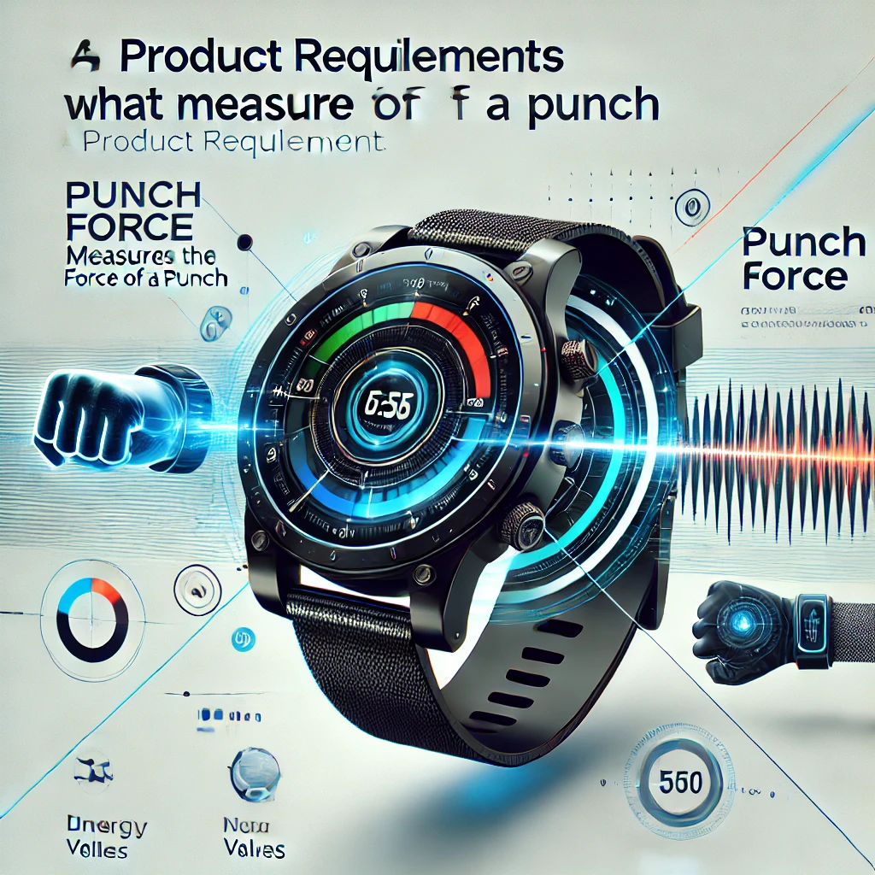

Step 1: Set Up the Project
- Install Xcode and ensure it's up-to-date.
- Create a new WatchOS app project in Xcode.
- Choose "App" under the WatchOS templates to build a standalone Watch app.

Step 2: Access the Accelerometer
- Use CoreMotion to interface with the accelerometer. You'll be using the CMMotionManager class to track motion data.

Step 3: Calculate Punch Force
- A punch's force can be estimated using the relationship between mass, acceleration, and velocity. While the accelerometer provides acceleration data, you'll need to process it to derive meaningful results:
  - Measure peak acceleration during a punch.
  - Factor in the user's arm weight (input or estimated) to calculate the force.

Step 4: User Interface
- Design a simple, intuitive interface:
  - Start/Stop punch measurement button.
  - Display real-time stats: punch force, speed, count, etc.
  - Add charts or animations for engagement.

Step 5: Additional Features
- Gamification: Add leaderboards or achievements.
- Training Modes: Include guided drills and feedback.
- Data Analysis: Show trends over time or per session.

